**Exp. 2** **Design Christmas Dual Led Chaser Lights**

Circuit Diagram:

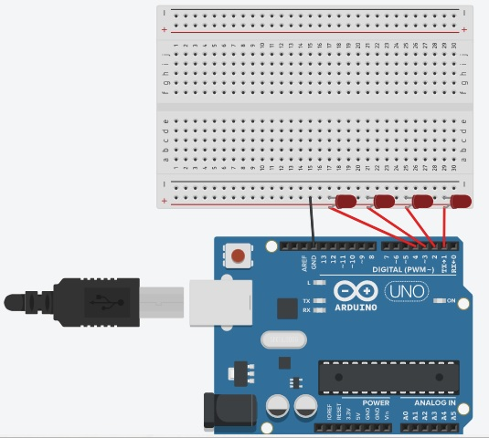

**Theory**

Concepts Used:

1. Worked with Arduino UNO
2. Circuitry of Breadboard and it’s use
3. Code with Arduino IDE and syntax of the same
4. Working of LED (Light emitting diodes)
5. Making connections on a Breadboard neat and clean.
6. For loop syntax and used.

Learning & Observations:

Coding in Arduino IDE: It is a very systematical way to show how the circuits are working. Syntax of coding is very similar to the coding in ‘C’ language which are being taught to us by teacher. I learn the importance of calculating delay as the micro-controller is very fast and capable.

I observed that there are many other interesting functions, like random function is fun to use.

Problems & Troubleshooting

I had to take about 3 attempt to find the right amount of delay so that the strip working on one LED at a time and also without any significant delaying in one LED turning OFF and the next LED turning ON.

Other than this I encounter no other issues.

Precaution to be taken

1. Remembered to declared all the ports in use in digital input/output in the right way.
2. Check whether all your wire pieces are working properly and correctly and all connections are good.
3. Remember to connect Negative terminalof device (in this case LED) to ground in Arduino Uno to ensures potential difference.
4. TRY to find right amount of delay by approximation and improvisation by trial so that the circuit performed at it is best.

Learning Outcomes

Skilled that I had acquired were sound knowledged of using Arduino UNO and a better idea of approximation by trialed.

I can now performed these things easily and smartly.